Database Development and Class Registration

Jeremy Robinson

CST499: Capstone for Computer Software Technology

January 17, 2023

Professor Elchouemi

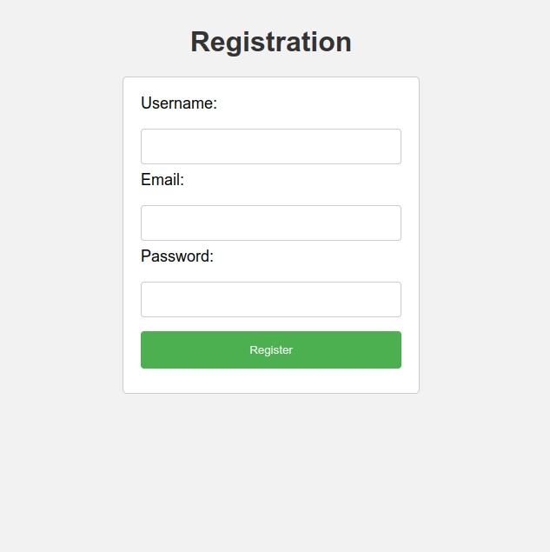Figure

This is the registration form of the users to the system. The system uses php and Mysql connection to check the credentials entered by users.

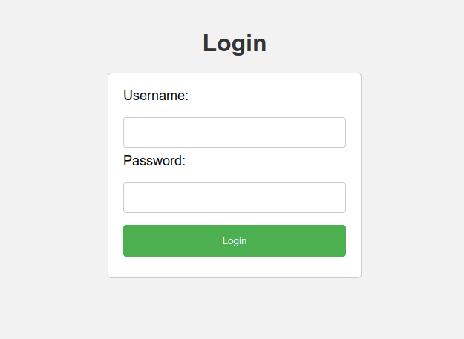

*Figure 2*

The figure above shows the login page. It requires the username and password. Users must be authenticated before accessing the system.

*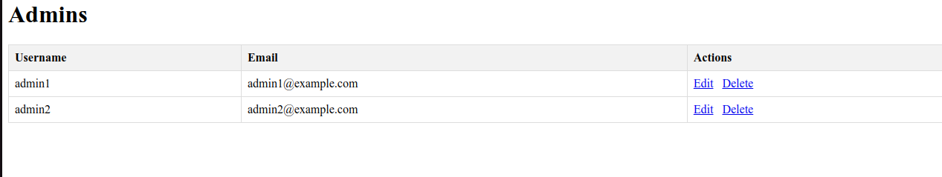Figure 3*

Above is the admin page. The admin is in charge of the entire system.

In the figure below, I have indicated the dashboard of the application.

On logging in, the users access this dashboard for further navigation.



**Databases Images**

**Educators Table**

Ut contains the educator id, firstname,lastname ,email, hiredate and theuir department.

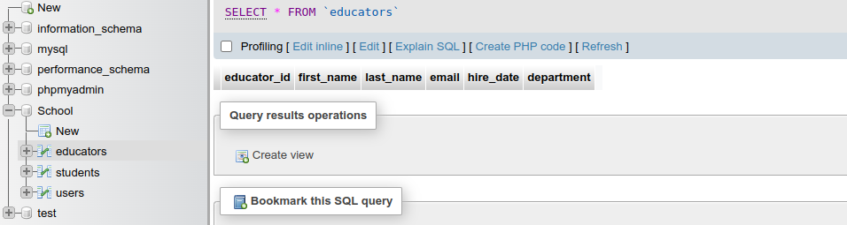

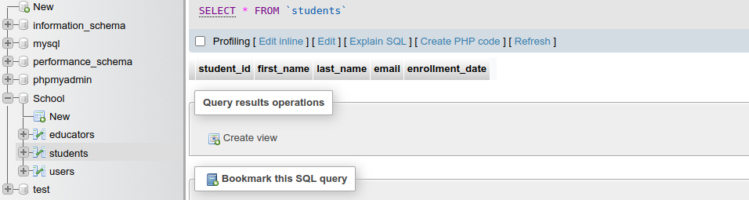**Student Table**

In the students table, the students data is kept here. It contains the id of the students, firstname,last name email and date of enrollment.

**Users Table**

Attached is the database of the users table. The users have the users id, username, email, password and roles collected and date of creation

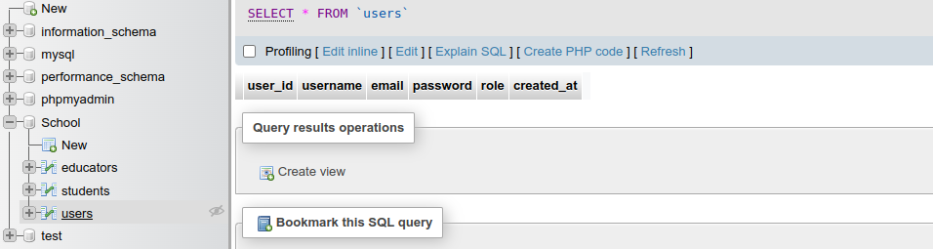

Finally is the overview of the tables in our database. Our database is of name school and has three tables that are co related.

.

